4: 283-287
Robotic transurethral electrovapourization of the prostate
M.S.NATHAN MS FRCS Durol, J.E.A.WICKHAMM SMD bscfrcsfrcp frcr & B.DAVIES MScEng PhD*
Department of Minimally Invasive Therapy, United Medical and Dental Schools of Guy's & St Thomas's Hospitals, London, and 'Department of Robotics, Imperial College London, UK
Summary. The need for an alternative management to transurethral resection of the prostate (TURP) is indicated because of its known post-operative morbidity and the increasing incidence of benign prostatic hyperplasia requiring operation with a considerably costlier effect on health care budgets. Despite the search, no beneficial alternative has yet emerged and it is envisaged that robotizing the procedure may be of benefit. The design of a purpose-built robot is described which consists of a specially designed motorized safety frame, a dedicated motion controller, an integrated ultrasound and camera system and a computer system. The software and the procedural protocol are briefly described. Clinical trial is in progress with a rapid set-up time of only 8min. It is concluded that the robot is ultimately expected to be an ideal alternative to conventional TURP.
Keywords: transurethral resection of the prostate, transurethral electrovapourization of the prostate, robotics in surgery, computer assisted surgery

Introduction
Although transurethral resection of the prostate (TURP) is acknowledged as the Gold Standard for prostatic enlargement, the search for an alternative management continues. This is for the following reasons:
- Post-operative morbidity has remained at a constant
rate of 18% over the last 2 decades.
- The operation is time-consuming and takes up nearly
38% of a Urologist's practice time and 80% of his opera
tive time [1].
- Numerous reports have indicated that the general age
ing of the world's population and the increased patient
awareness will increase the pressure on Urologists
and oversubscribe their resources [2],
- TURP is among the top expenditures for health authori-
ties and nearly 50% of the cost relates to hotel services
[3].
- When large prostate glands are resected the incidence
of post-operative complications dramatically increases,
thus limiting its application.
Correspondence: r M.S. Nathan, Associate Lecturer, Department of Minimally Invasive Therapy, United Medical & Dental Schools of Guy's & St Thomas's Hospitals, New Guy's House, London SE1 7RT, UK.
• TURP is a highly skilled procedure requiring a considerable time to learn, thus preventing the rapid dispersal of the technique.
Any alternative management to TURP should have the same or even better success rate than TURP. It would be advantageous if the procedure is non-invasive or at least not more invasive than TURP but also allowing prostate glands larger than 60 g to be treated. An ideal alternative should be easy to learn, quicker to perform, cost-effective and reduce hospital stay. Most importantly it should be associated with less morbidity and mortality than TURP.
Success rates comparable to TURP are reported only with open prostatectomy, stents, laser ablation of the prostate and transurethral electrovapourization of the prostate (TUEP) (Table 1).
Open prostatectomy is a major invasive procedure with a higher post-operative morbidity and mortality than TURP. Stents are very effective in relieving obstruction but the imperfect 3-D fit of the prosthesis in the prostatic urethra leads to distressing post-operative irritative symptoms, thus partially defeating the purpose of the procedure.
Laser ablation of the prostate is reported to have a comparable success rate to TURP but long-term results are predicted to be poor. Frequently patients require

© 1995 Blackwell Science Ltd

283

284 M.S. Nathan et al.
Table 1. Comparison of TURP with its alternatives

Procedure
Success rate (%)
Advantages
Disadvantages

85-95
90
73

TURP [4]
Open prostatectomy [5]
Transurethral incision of the
prostate [6]
85-95

76

30-50

60

40-55

30

74-94

50

40

50

50-70
TUEP [7]
Visual laser ablation of the
prostate [8]
Transurethral ultrasound-guided
laser-induced prostatectomy [9]
High intensity focussed
ultrasound [10]
Drugs
Cryotherapy
Urethral stents[11]
Transurethral microwave
thermotherapy [12]
Microwave hyperthermia [13]
Transurethral needle ablation [14]
Time-honoured 'Gold Standard' Low re-operation rate Quick, low morbidity
Low morbidity, day case procedure Quick, day case
Quick, day case, focus of laser is well controlled
Non-invasive
Non-invasive
Day case, anticoagulated patients can be safely done
Quick
Day case, no anaesthetic
No anaesthetic
Day case
Day case
High failure rate
18% morbidity, large glands are risky
20% morbidity, major invasive surgery
Only small glands can be done, high failure and re-operation rate
? Slow, prolonged dysuria
Prolonged post-operative catheterization, dysuria
Prolonged post-operative catheterization, dysuria, UTI
Costly, slow and tedious
Life-long therapy, intolerable side effects
Hazardous in small glands and ineffective in large ones
-Severe irritative bladder symptoms, costly
Repeated sessions may be required, high failure rate
Unacceptable failure rate
Prolonged haematuria, dysuria, 20% acute retention

Balloon dilatation [15]

long-term catheterization and the presence and passage of necrotic tissue leads to a high incidence of urinary infection and bacteraemia. The equipment is costly and defeats any savings made by reducing the hospital stay.
TUEP has similar short-term success rates to TURP but with considerably lower morbidity rate and no mortality. Prostate glands over 80 g have been safely vapourized and anticoagulation does not pose a contraindication to the procedure. As minute peroperative bleeding occurs, hypotensive anaesthesia is not necessary and patients with compromised coronary and cerebral circulation can be safely treated. Patients can often go home within 24 h, thus dramatically reducing the hospital stay. The procedure does not require any special equipment and long-term results are expected to be the same as TURP. Despite these advantages the procedure is technically as demanding as TURP and has been criticized as being slower.

From the above discussion it can be seen that currently TUEP offers the best alternative to TURP although it is technically as difficult as a TURP, probably slower and in some cases is associated with post-operative dysuria that sometimes lasts for up to 6 weeks. With the same operating time as TURP, the turnover of patients in the operating theatre would be the same with no major benefit to the waiting list. As it has the same complexity as TURP requiring considerable time to learn, the dispersal of the technique would not be rapid. It would thus be desirable to accelerate and de-skill the operation. Automation of TUEP would achieve both these objectives making it the ideal alternative to TURP. The advantages of automation of the procedure are shown in Figure 1.

Materials
The prostatectomy robot consists essentially of a motorized safety frame attached to an electronic gantry, a camera system and a console housing a computer, diathermy
unit, ultrasound scanner and a motion controller. The motorized safety frame consists of a linear head travel attached to the electronic gantry with a ball clamp so that it can be positioned and clamped freely at any angle. The head travel consists of a ball screw driven by a DC motor. The screw is flanked on either side by two supporting rails. A carriage carrying an aluminum ring assembly rides on the screw and the rails. The aluminum ring assembly consists of a base ring with four nylon rollers positioned at 2, 4, 8 and 10 o'clock positions. The rollers have V-shaped grooves to fit with a second aluminum ring with a V-shaped circumferential edge. The 10 o'clock roller has grooves to engage with helical gear teeth cut on the circumference of the second ring and is motor driven to rotate the ring through 360'.
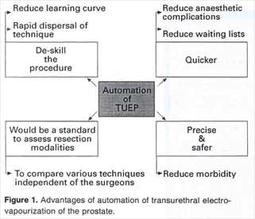

.

The second ring has a diametrical arch with an aluminum carriage attached to it. A 27Ch continuous ACMI resectoscope with a rack and pinion is fitted to the carriage. The cutting handle of the resectoscope is replaced with a DC motor equipped with a pinion so that its motions move the resectoscope loop forward and in reverse (Figure 2).
The linear travel allows craniocaudal movement so that the length of the resection can be varied. The ring allows movement through 360C while the carriage can be moved
Figure 2. Automated transurethral ultrasound scan in progress. Note the electronic gantry with the motorized frame attached to it and the four DC servomotors can also be seen.
radially on the arch through 180'. With incremental movements of the ring and the arch a conical motion is swept out about a pivot point located towards the tip of the resectoscope while the stroke of the resectoscope loop or the vaportrode determines the length of the cone. By moving the linear travel, successive cones are resected. Each cone can have a maximum diameter of 48mm at its base and a length of 20 mm long. By overlapping successive cones, a truncated cone with a maximum dimension of 48mm at its base and 70mm long with a volume of 85cm3 can be resected.

The Electronic Gantry is essentially a counterbalance allowing five axial movements so that the tip of the resectoscope can be easily placed in any position. All the axial movements are controlled by electronic brakes that can be released or activated by a foot pedal. This allows great freedom in movement while locking its position in a snap with the release of the pedal.
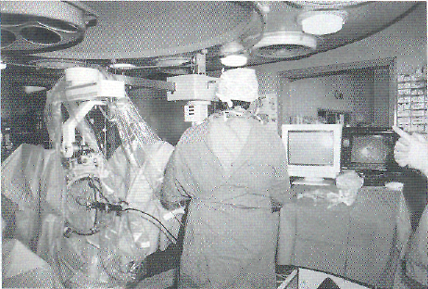
A four-axes Motion Controller controls the position, speed and acceleration of the four motors that drive the safety frame. It is programmed to carry out designated sequential motions in a co-ordinated way. For example, the overhead travel motor is first powered to position the tip of the resectoscope 2cm distal to the bladder neck. This is followed by the rotation of the ring by the ring motor to face the resectoscope towards the 2 o'clock position. The cutter motor is then powered to protrude the resectoscope loop. The arch motor and the diathermy unit are simultaneously made active to bite into the prostate and finally the cutter motor is again powered to retract the loop. To control each of these movements directly by a computer will make the motions very slow while the motion controller acts as a local command and quickens the pace. The sequences of movements are programmed into the motion controller and when a command from the computer arrives the whole sequence is born. The motion controller is programmed to carry out different sequences with varying computer commands.
A Valleylab Force 40 Diathermy Unit similar to the ones used for conventional TURP was modified to respond to the motion controller. On receiving the command from the IBM computer the motion controller relays it to the mother boards controlling the motions of the arch and the cutter motors. These mother boards simultaneously power their motors to move the carriage or retract the loop or vaportrode while closing the cutting foot switch terminal and the loop to first bite into the tissue and then retract.
For safety purposes, a manual switch is installed to stop the current flow through the loop in case of failure of the computer to stop the flow after retracting the loop.

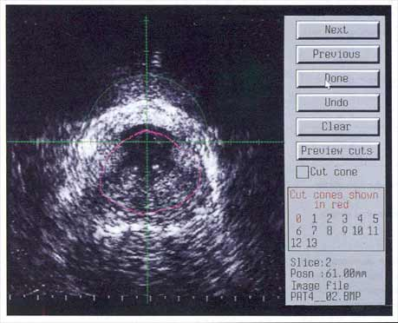

Figure 3. Presentation of transurethral ultrasound images to delineate the area of resection
A Bruel and Kjaer Ultrasound Scanner using a 7.5 MHz transurethral transducer is incorporated into the prostatectomy robot. The ultrasound machine is linked to the computer so that its images are automatically enhanced and stored by the computer.
The Computing System consists of an IBM AT microcomputer that is the top level supervisory controller of all the subsystems. The computer controls the motion controller and the diathermy unit but can be overridden by an emergency stop switch. The software was purpose written in ASCII mode and contains stepwise commands that require the surgeons' permission for every motion of the robot making it inherently safe. On-line text information about the position of the motors, 3-D graphic and visual images of the resectoscope and the loop is displayed on the monitor.

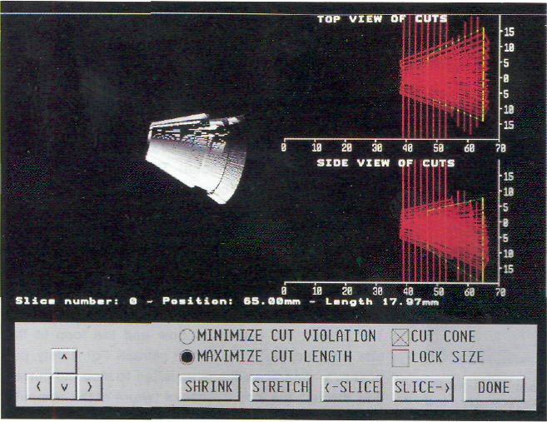

Figure 4. Three-dimensional model of the resection

.
© 1995 Blackwell Science Ltd. Minimally Invasive Therapy, 4, 283-287

References
- Holtgrewe HL, Mebust WK, Dowd JB, Cockett ATK, Peters PC, Proctor C. Transurethral prostatectomy: practice aspects of the dominant operation in American urology. J Urol 1989;141: 248-53
- McKelvie GB, Collins GN, Hehir M, Rogers ACN. A study of benign prostatic hyperplasia - a challenge to British urology. Br J Urol 1993; 71: 38-42
- Drummond MF, McGuire AJ, Black NA, Petticrew M, McPher-son CK. Economic burden of treated benign prostatic hyperplasia in the UK. Br J Urol 1993; 71: 290-6
- Kuo H, Chang S, Hsu T. Predictive factors for successful surgical outcome of benign prostatic hyperplasia. Eur Urol 1993; 24:12-9 j
- Montorsi F, Guazzoni G, Bergamaschi F, Consonni P, Matozzo V, Barbieri L, Rigatti P. Long term clinical reliability of transurethral and open prostatectomy for benign prostatic obstruc
tion: a term of comparison for nonsurgical procedures. Eur Urol 1993; 23: 262-6
- Madsen FA, Bruskewitz RC. Transurethral incision of the prostate. Urol Clin N Am 1995; 22: 369-73
- Kaplan SA, Te AE. Transurethral electrovaporization of the prostate: a novel method for treating men with benign prostatic hyperplasia. Urology 1995; 45: 566-72
- Morris JP, Norris DM, Lee RD, Rubenstein MA. Visual laser ablation of the prostate: a clinical experience in 108 patients. J Urol 1993; 150:1612-5
- McCullough DL, Roth RA, Babayan RK, Gordon JO, Reese JH. Transurethral ultrasound-guided laser-induced prostatectomy: National Human Co-operative Study results. J Urol 1993; 150: 1606-12
- Maderbacher S, Kratzik C, Szabo N, Susani M, Vingers L, Marberger M. Tissue ablation in benign prostatic hyperplasia with high intensity focused ultrasound. Eur Urol 1993; 23 (Suppl.1):39-43
- Milroy E, Chappie CR. Urolume stent in the management of benign prostatic hyperplasia. J Urol 1993; 150:1630-5
- Schulman CC, Bossche MV. Hyperthermia and thermotherapy of benign prostatic hyperplasia: a critical review. Eur Urol 1993; 23 (Suppl.1): 53-9
- Venn SN, Montgomery BSI, Sheppard SA, Hughes SW, Beard RC, Bultitude Ml etal. Microwave hyperthermia in benign pro-static hyperplasia: a controlled clinical trial. BrJUrol 1995; 76:73-6
- Dixon CM. Transurethral needle ablation for the treatment of benign prostatic hyperplasia. Urol Clin N Am 1995; 22: 441-4
- Dowd JB, Smith JJ. Balloon dilatation of the prostate. Urol Clin N Am 1990;17:671-8

©1995 Blackwell Science Ltd, Minimally Invasive Therapy, 4, 283-287

